The HAL Company

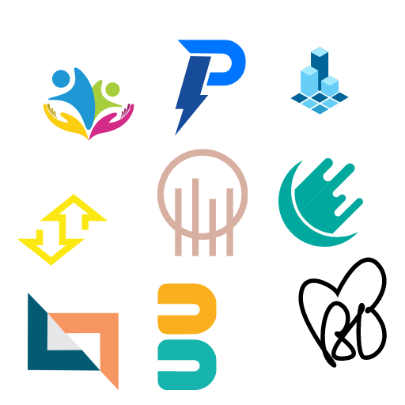



**The Indigo Project**

Date: 19th January 2024

To: Armand Harmon (C.E.O)

CC: Michele Lenox (C.P.O)

From: Christian Spalluto, William Salhany, Randolph Svitzer (Project Managers)

The Indigo project is estimated to cost $686,508.40 with detailed product design being the most expensive task. The Design Engineers commands the greatest total cost being $186,930.00. The month with the highest cost is May in 2025 totaling $192,823.30 and the lowest cost is in November of 2025 totaling $2,189.60. Costs may vary between June 2026 and July 2026 due to the scope of installing production equipment.